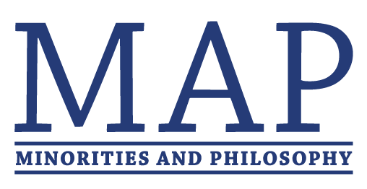
MAP FUNDING APPLICATION

Thanks for your interest in MAP. Funding from MAP is limited and intended only for those chapters that can’t secure sufficient funding from their departments or universities. Typically, chapters may apply for a maximum of $500/semester, but exceptions may be made for special events.

To qualify for funding from MAP, your chapter must (a) demonstrate an inability to secure enough funding, and (b) have been functional for at least one semester. Chapters will be expected to provide receipts for all purchases made with MAP funds.

Please notice that funds must be spent in the calendar year that they are received, and plan your application accordingly. If you want to request funds for an event to be held in a later semester, please email mapforthegap@gmail.com to discuss your options.

Funding applications will be considered incomplete and will be returned if any of the below questions are left unanswered. (“N/A” can be an appropriate answer.)

To apply for funding, please fill out this form and email it to mapforthegap@gmail.com by February 2, 2020. You should hear back from us by February 6, 2020. Please send it as a .doc or .pdf and name the file with your Chapter’s name.
----------------------------------------------------------------------------------------------------------------------------

- How much are you requesting in total from MAP International?

We will not consider funding requests over $500.

- Include an itemized budget for (at least) the funds that you are requesting. (Please be as detailed as possible (e.g. include possible vendor and their estimates of cost).

We will not consider funding requests that do not include an itemized budget.

- What steps have you taken to secure funding from your department/university? What has the response been (e.g. Guaranteed, Pending, Refused)?
  - Estimate of available funding from department:
  - Estimate of available funding from university:

- Identify other sources of potential funding:
- Describe the nature of your event or activity and how it exemplifies or furthers MAP’s goals.
- If you have put on a similar event in the past, what was the estimated budget? What changes in funding source or budget do you anticipate?

- Since MAP has grown exponentially in size (and not in funds), we can now typically only grant partial funding. Given this, please tell us which items you’d like prioritized for funding purposes.

- At the request of our funders, we are now moving toward reimbursement as the default payment method for tax purposes. This requires you to submit receipts (along with a funding cover sheet, as a single PDF) at the end of the semester or when you have spent your allotted funds (whichever comes first, or is more convenient). You may also provide us with payment information at the time you submit receipts for reimbursement. We are sensitive to the difficulties this poses to graduate students. If fronting the funds you need for your event would be overly burdensome, we have a very limited amount of funding that we can disburse ahead of time to cover the costs of your event. Please email mapforgap@gmail.com to request this.
We reimburse funding via (i) Zelle/PayPal or (ii) check/bank transfer. We prefer (i) if possible. Please provide account information of (i) or (ii):

(i) Zelle or PayPal account (indicate which one):

Or

(ii) For North American chapters:
Check Addressee:
Check Address:

For chapters outside of North America:
It is a business or personal account?:
Recipient’s First & Last Name OR Business Name:
Recipient’s Address:
City:
Country:
Postal Code:
Recipient’s Email Address:
Sort Code OR IBAN (indicate which one):

Unless it’s a special event (e.g. a large regional event), in which case the cap is $1,000. If it’s a special event, please use the “Special Event” application instead (found here).
Check out our ‘how to’ guide on fundraising from faculty here.

