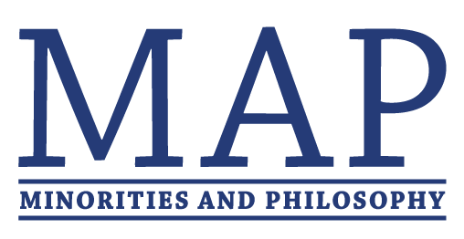
MAP FUNDING APPLICATION

Thanks for your interest in MAP. Funding from MAP is limited and intended only for those chapters that can’t secure sufficient funding from their departments or universities.Typically, chapters may apply for a maximum of $500/semester, but exceptions may be made for special events.

To qualify for funding from MAP, your chapter must (a) demonstrate an inability to secure enough funding, and (b) have been functional for at least one semester. Chapters will be expected to provide receipts for all purchases made with MAP funds.

Please notice that funds must be spent in the calendar year that they are received, and plan your application accordingly. If you want to request funds for an event to be held in a later semester, please email mapforthegap@gmail.com to discuss your options.

To apply for funding, please fill out this form and email it to mapforthegap@gmail.com by February 10, 2017. You should hear back from us in 1-2 weeks.
----------------------------------------------------------------------------------------------------------------------------

- Estimate of available funding from department:
- Estimate of available funding from university:

- Identify other sources of potential funding:

- What steps have you taken to secure funding from your department/university? What has the response been?

- How do you plan on using these funds? If you have secured some form of funding already, please indicate the amount and describe what you hope to do with additional funding from MAP. Please include an itemized budget for any request over $200.

- If your application is accepted, we will distribute the funds to your department so that you may use those funds to pay for your activities. Please write the department mailing address and addressee for the check.

